COMP 7500 Lecture 03: Shared-Memory Systems
: >85%, : 70-85%, : 55-70%, : 40-55%, : < 40%
Exercise 1: (1.1) Which IPC model is shared memory and which one is message passing? (1.2) Which IPC model do you prefer? why? (1 Minute)

Exercise 2 (Review): Suppose two processes are exchanging a small amount of data, which interprocess communication model will you choose? Why?
- Shared Memory
- Shared Buffer
- Message Passing
- Message Chatting

Exercise 3 (Review): Which interprocess communication model is faster than its counterpart? Assumption: message-passing systems are implemented using system calls; shared-memory regions are implemented in the user space.
- Message Passing is faster
- Shared Memory is faster
- Shared Message is faster
- Two models are both fast

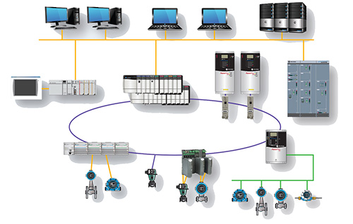
Exercise 4 (Review): Which interprocess communication model is easier to implement in a distributed system?
- Shared Memory is easier
- Message Passing is faster
- Message Passing is easier
- Two models are equally easy

Exercise 5 (MS Forms): Where should the shared memory region reside? (30 Seconds)
- Process A
- Process B
- Randomly pick process A or B
- The process that creates the shared memory region

Exercise 6: Please read the following sample source code. Can you design a diagram to intuitively illustrate the shared memory mechanism?
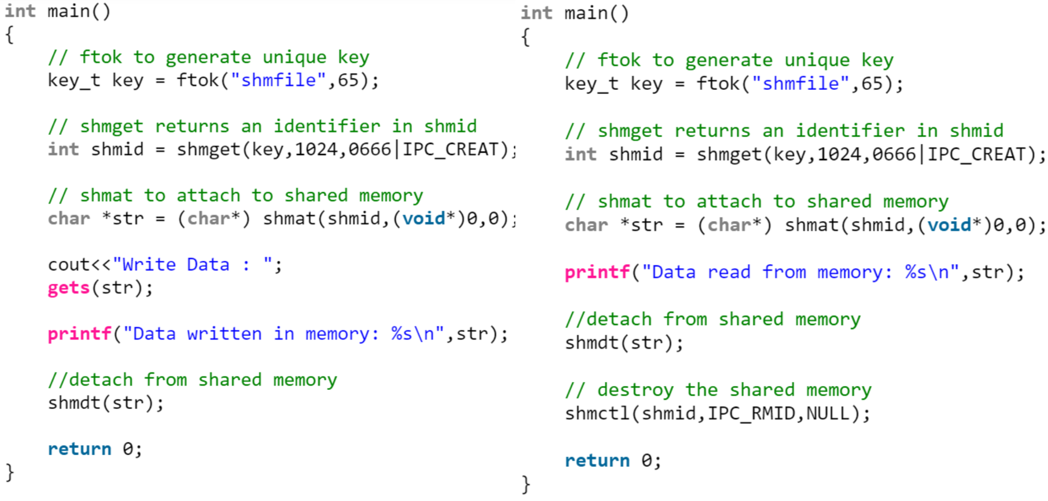

Exercise 7: Please complete the following code for the producer process.
item next_produced;
while (true) {
/* produce an item in next produced */
while (((in + 1) % BUFFER_SIZE) == __________) /*buffer is full*/
; /* do nothing */
buffer[in] = __________________________;
in = ___________________________; /*Hint: go to the next buffer*/
}

Exercise 8: Please complete the following code for the consumer process.
item next_consumed;
while (true) {
while (in == __________)
; /* do nothing */
next_consumed = __________________________;
out = ____________________________________;
/* consume the item in next consumed */
}

Exercise 9 (MS Forms): What issue hasn’t been addressed in the above producer-consumer solution? (30 Seconds)
- No issue. It is a perfect solution.
- There a debugging problem
- There is a race condition problem
- There is a user-space problem

